LAB 2:

PHẦN I

Bài 1: Thực thể và thuộc tính
Thực thể:
- Customer
- Product
- Invoice
- Invoice_Detail
Thuộc tính:
Customer: customer_id (PK), customer_name, phone, address
Product: product_id (PK), product_name, price
Invoice: invoice_id (PK), created_date, customer_id (FK), total_amount
Invoice_Detail: invoice_id (FK), product_id (FK), quantity, unit_price, PK(invoice_id, product_id)

Bài 2: Chuẩn hóa
1NF: Tách danh sách sản phẩm thành bảng riêng.
2NF: Tách Product khỏi Invoice_Detail.
3NF: Tách Customer khỏi Invoice.
Kết quả: 4 bảng đạt chuẩn 3NF.

PHẦN II

Bài 3: Khóa và quan hệ
PK:
Customer: customer_id
Invoice: invoice_id
Product: product_id
Invoice_Detail: (invoice_id, product_id)
FK:
Invoice.customer_id → Customer
Invoice_Detail.invoice_id → Invoice
Invoice_Detail.product_id → Product
Quan hệ:
Customer – Invoice: 1-N
Invoice – Invoice_Detail: 1-N
Product – Invoice_Detail: 1-N

Bài 4: ERD
Sơ đồ quan hệ:
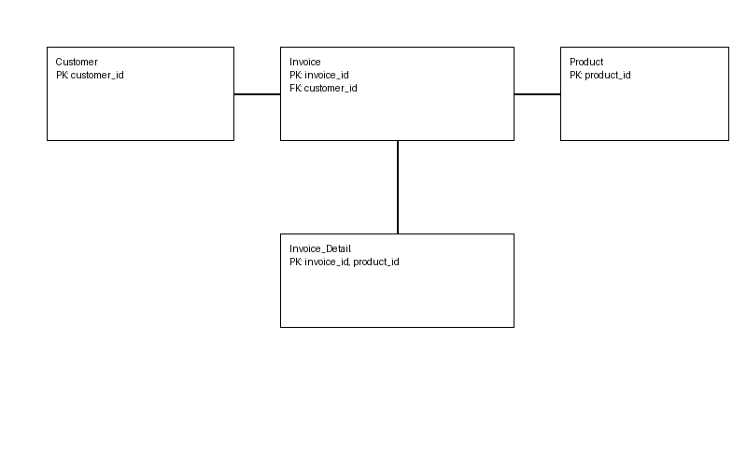

PHẦN III: SQL (PostgreSQL)
CREATE TABLE customer (
customer_id SERIAL PRIMARY KEY,
customer_name VARCHAR(255),
phone VARCHAR(20),
address VARCHAR(255)
);
CREATE TABLE product (
product_id SERIAL PRIMARY KEY,
product_name VARCHAR(255),
price DECIMAL(10,2)
);
CREATE TABLE invoice (
invoice_id SERIAL PRIMARY KEY,
created_date DATE,
customer_id INT,
total_amount DECIMAL(10,2),
FOREIGN KEY (customer_id) REFERENCES customer(customer_id)
);
CREATE TABLE invoice_detail (
invoice_id INT,
product_id INT,
quantity INT,
unit_price DECIMAL(10,2),
PRIMARY KEY (invoice_id, product_id),
FOREIGN KEY (invoice_id) REFERENCES invoice(invoice_id),
FOREIGN KEY (product_id) REFERENCES product(product_id)
);

